1. Given the following state transition diagram Which of the following series of state transitions contains an INVALID transition which may indicate a fault in the system design?
Exhibit:
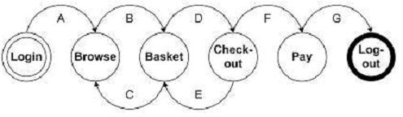
A. Login Browse Basket Checkout Basket Checkout Pay Logout.
B. Login Browse Basket Checkout Pay Logout.
C. Login Browse Basket Checkout Basket Logout.
D. Login Browse Basket Browse Basket Checkout Pay Logout
2. Given the following fragment of code, how many tests are required for 100% decision coverage?
if width > length then
biggest_dimension = width
if height > width then
biggest_dimension = height
end_if
else
biggest_dimension = length
if height > length then
biggest_dimension = height
end_if
end_if
A. 3
B. 4
C. 2
D. 1
3. You have designed test cases to provide 100% statement and 100% decision coverage for the following fragment of code.
if width > length then
biggest_dimension = width
else
biggest_dimension = length
end_if
The following has been added to the bottom of the code fragment above.
print "Biggest dimension is " & biggest_dimension
print "Width: " & width
print "Length: " & length
TURN OVER TO NEXT PAGE FOR OPTIONS.
How many more test cases are required?
A. One more test case will be required for 100 % decision coverage.
B. Two more test cases will be required for 100 % statement coverage, one of which will be used to provide 100% decision coverage.
C. None, existing test cases can be used.
D. One more test case will be required for 100" statement coverage.
4. A wholesaler sells printer cartridges. The minimum order quantity is 5. There is a 20% discount for orders of 100 or more printer cartridges. You have been asked to prepare test cases using various values for the number of printer cartridges ordered. Which of the following groups contain three test inputs that would be generated using Boundary Value Analysis?
A. 5, 6, 20
B. 4, 5, 80
C. 4, 5, 99
D. 1, 20, 100
5. In a Examination a candidate has to score minimum of 24 marks inorder to clear the exam. The maximum that he can score is 40 marks. Identify the Valid Equivalance values if the student clears the exam.
A. 22,23,26
B. 21,39,40
C. 29,30,31
D. 0,15,22
6. One of the fields on a form contains a text box which accepts alpha numeric values. Identify the Valid Equivalence class
A. BOOK
B. Book
C. Boo01k
D. book
7. One of the fields on a form contains a text box which accepts numeric values in the range of 18 to 25. Identify the invalid Equivalance class
A. 17
B. 19
C. 24
D. 21

8. In a system designed to work out the tax to be paid: An employee has $4000 of salary tax free. The next $1500 is taxed at 10% The next $28000 is taxed at 22% Any further amount is taxed at 40%
Which of these groups of numbers would fall into the same equivalence class?
A. $5800; $28000; $32000
B. $0; $200; $4200
C. $5200; $5500; $28000
D. $28001; $32000; $35000
9. Which test suite will check for an invalid transition using the diagram below?
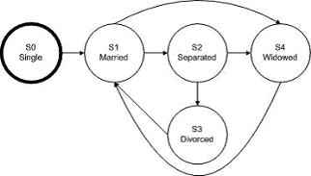
A. S0-S1-S2-S3-S1-S4
B. S0-S1-S4-S1-S2-S3
C. S0-S1-S3-S1-S2-S1
D. S0-S1-S2-S3-S1-S2
10. According to the ISTQB Glossary, the word 'bug' is synonymous with which of the following words?
A. Incident
B. Defect
C. Mistake
D. Error
11. test team consistently finds between 90% and 95% of the defects present in the system under test. While the test manager understands that this is a good defect-detection percentage for her test team and industry, senior management and executives remain disappointed in the test group, saying that the test team misses too many bugs. Given that the users are generally happy with the system and that the failures which have occurred have generally been low impact, which of the following testing principles is most likely to help the test manager explain to these managers and executives why some defects are likely to be missed?
A. Exhaustive testing is impossible
B. Defect clustering
C. Pesticide paradox
D. Absence-of-errors fallacy

12. According to the ISTQB Glossary, regression testing is required for what purpose?
A. To verify the success of corrective actions.
B. To prevent a task from being incorrectly considered completed.
C. To ensure that defects have not been introduced by a modification.
D. To motivate better unit testing by the programmers.
13. If you are flying with an economy ticket, there is a possibility that you may get upgraded to business class, especially if you hold a gold card in the airline's frequent flier program. If you don't hold a gold card, there is a possibility that you will get 'bumped' off the flight if it is full and you check in late. This is shown in following Figure. Note that each box (i.e. statement) has been numbered.
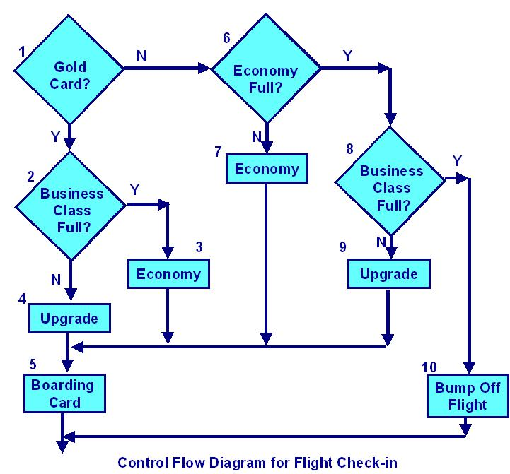
Three tests have been run:
Test 1: Gold card holder who gets upgraded to business class
Test 2: Non-gold card holder who stays in economy
Test 3: A person who is bumped from the flight
What is the statement coverage of these three tests?
A. 60%
B. 70%
C. 80%
D. 90%
14. Given the state diagram in following Figure, which test case is the minimum series of valid transitions to cover every state?
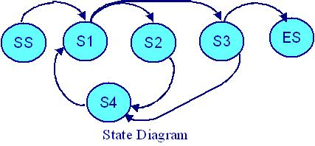
A. SS - S1 - S2 - S4 - S1 - S3 - ES
B. SS - S1 - S2 - S3 - S4 - S3 - S4 - ES
C. SS - S1 - S2 - S4 - S1 - S3 - S4 - S1 - S3 - ES
D. SS - S1 - S4 - S2 - S1 - S3 – ES
15. Consider the following decision table for Car rental.
Conditions | Rule 1 | Rule 2 | Rule 3 | Rule 4
Over 23? | F | T | T | T
Clean driving record? | Don't care | F | T | T
On business? | Don't care | Don't care | F | T
Actions
Supply rental car? | F | F | T | T
Premium charge | F | F | F | T
Given this decision table, what is the expected result for the following test cases?
TC1: A 26-year-old on business but with violations or accidents on his driving record
TC2: A 62-year-old tourist with a clean driving record
A. TC1: Don't supply car; TC2: Supply car with premium charge.
B. TC1: Supply car with premium charge; TC2: Supply car with no premium charge.
C. TC1: Don't supply car; TC2: Supply car with no premium charge.
D. TC1: Supply car with premium charge; TC2: Don't supply car.

